Project funded by:
PILLAR III. TRANSFORMATION OF RTDI SYSTEM
COMMERCIAL EXPLOITATION OF RESEARCH RESULTS (STAGE A)
RESEARCH AND INNOVATION FOUNDATION (RIF)
RESTART 2016-2020

DineTours

Deliverable Number
Deliverable Title
Intellectual Output Title
Activity description
Organisations/Contributors
Status (D: draft; RD: revised draft; F: final)
Date (versioning)

Document History

Authors | Reviewer | Date | File suffix  [Version.Revision] | Approval
Organizations | Organization | 01.03.2019 | 1.0 | Organization Yes

Executive Summary

List of abbreviations

Abbreviation | Definition

Table of contents
1. Introduction 7
1.1. Heading 2 7
1.1.1. Heading 3 7
2. Graph 7
References 7
Annexes 7

List of Figures

Figure 1: Graph 7

Introduction

Heading 2

Heading 3

Graph
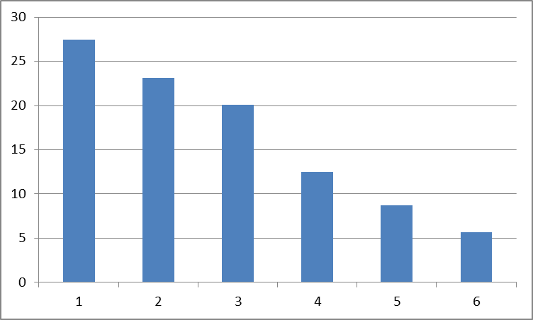
Figure 1: Graph

References
[1] Christos Mettouris, Achilleas Achilleos, Georgia Kapitsaki and George Papadopoulos, "A Model Driven Development Framework for Recommender Systems in Ubiquitous Environments for Commerce", European Conference on Ambient Intelligence (AmI 2018), Towards a Smart and Human Centered Internet of Things, Springer, 2018.

Annexes

